- SKETCHING – beyond craft to design: the importance of alternatives.
Design is what people do. When we are being “more than animals”. (s1)
Sketches are an essential designer’s tool for capturing preliminary observations and ideas. If they are fluent and flexible they support creativity. Sketches can be concrete or abstract, representational or symbolic, loose or tight, improvisational or rehearsed. (s2)
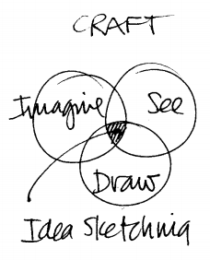
Robert McKim in Experiences in Visual Thinking teaches how to draw by teaching how to see and how to imagine. Seeing feeds drawing, drawing improves seeing. What we see is influenced by what we imagine; what we imagine depends on what we see. McKim’s creative ideal of rapid visualization or idea sketching is the craft of doing all three at the same time. This is similar to the experience of any craftsman in direct engagement with his materials: imagining, shaping, seeing all at the same time.

